**BSc (Hons)**

**in Information Technology**



**IT3021 – Data Warehousing & Business Intelligence**

**Assignment 02**

Submitted By:

Botheju W.M.N

IT20139230

**Step 1: Data source for the assignment**

Used IT20139230_DW data warehouse which I have implemented and loaded with data in assignment 1 as the data source for the assignment 2

It contains five dimension tables and one fact table which including measure values of the data source.

❑ **DimCustomerDetails**- Details about the Customer

❑ **DimCustomerServiceDetails**- Details of the services for the customer

❑ **DimLocation**- Details of the customer loction

❑ **DimDate**- Hierarchical Details of the dates

❑ **FactChurn**- Details of the Churn Status and Usage of the customer

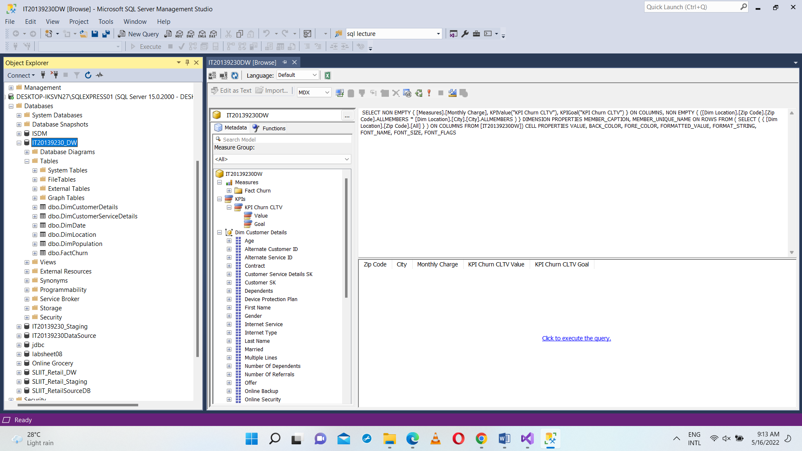

ER Diagram:

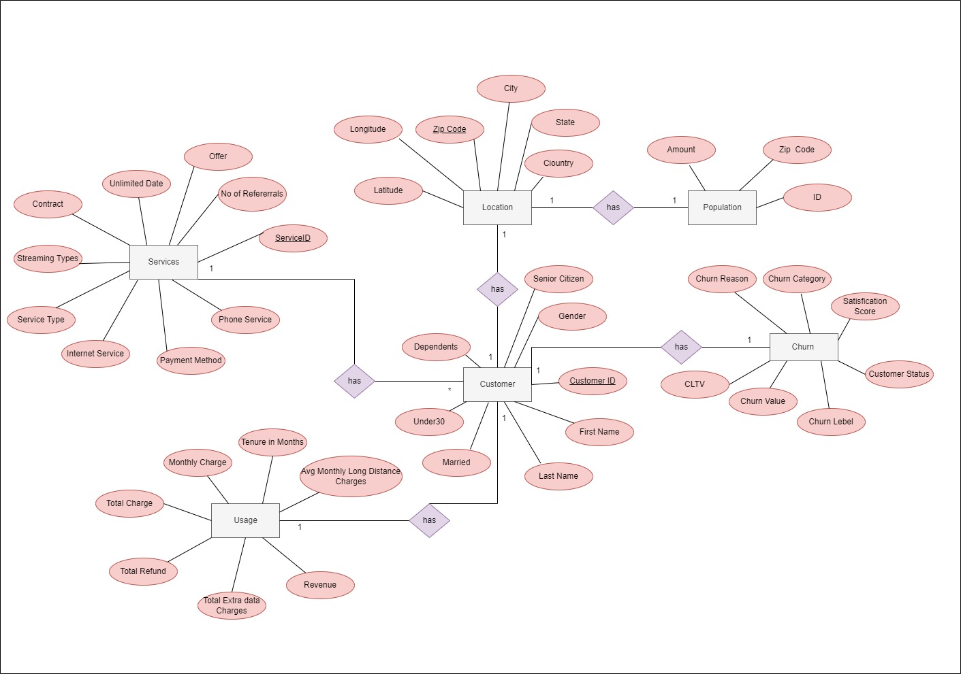

Data warehouse Design:



**Step 2: SSAS Cube implementation**

A new SSAS project was created which named as IT201339230_SAAS to begin the SSAS cube implementation. There after created IT20139230-DW Data warehouse was added as a new Data source and configurations were done.

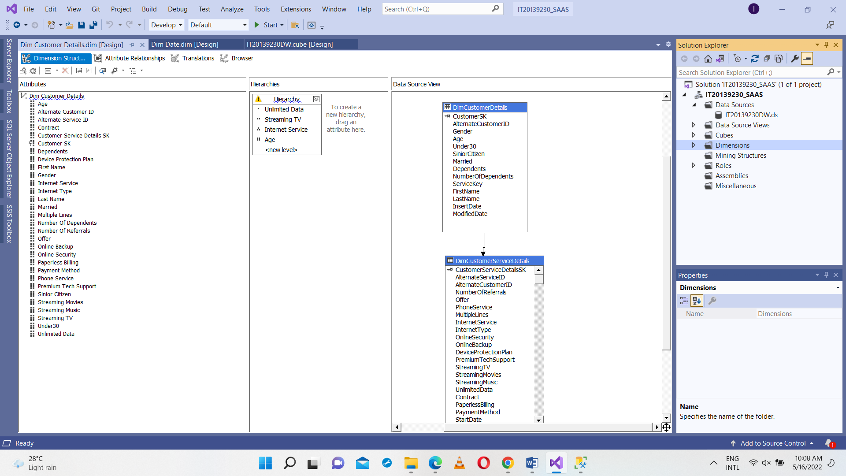

After selected IT20139230_DW as a data source and included all the dimensions and Fact table.

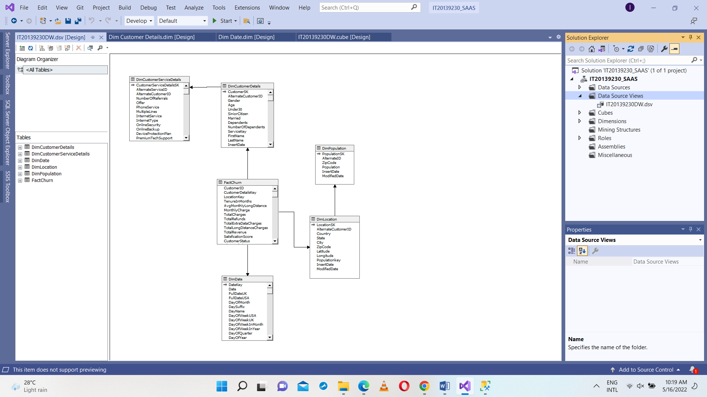



20139230DW.dsv Design

Next a cube was created by adding a new cube and selected the FactChurn table as the measures.

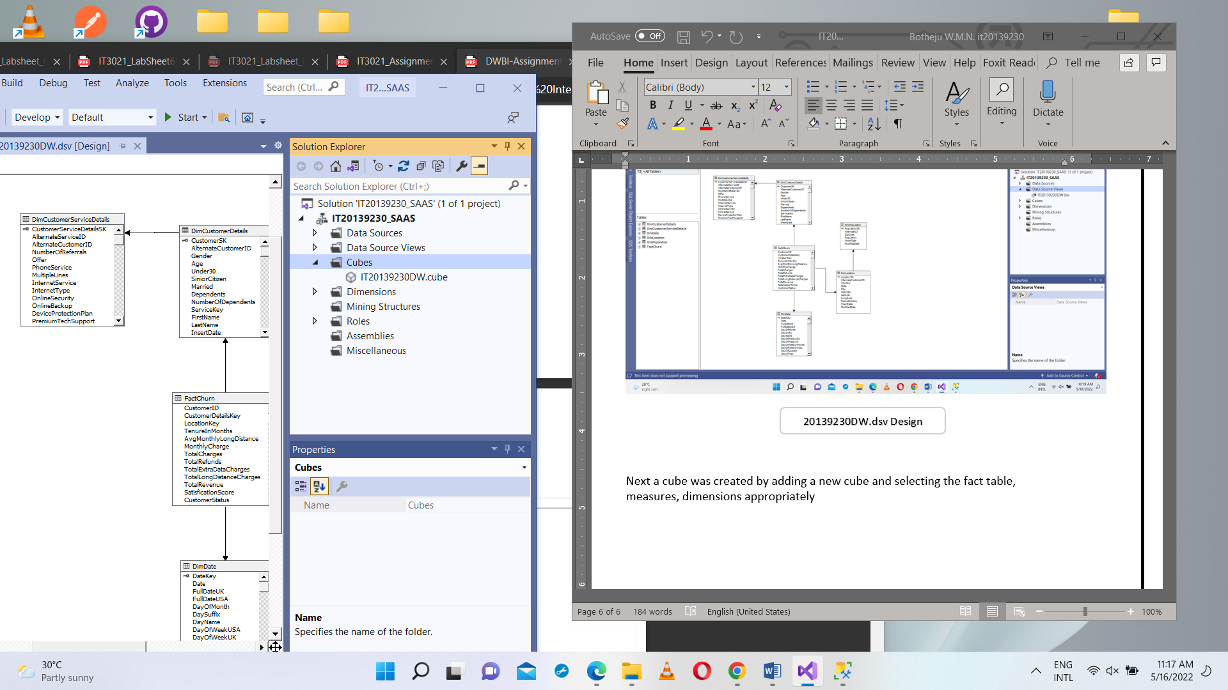

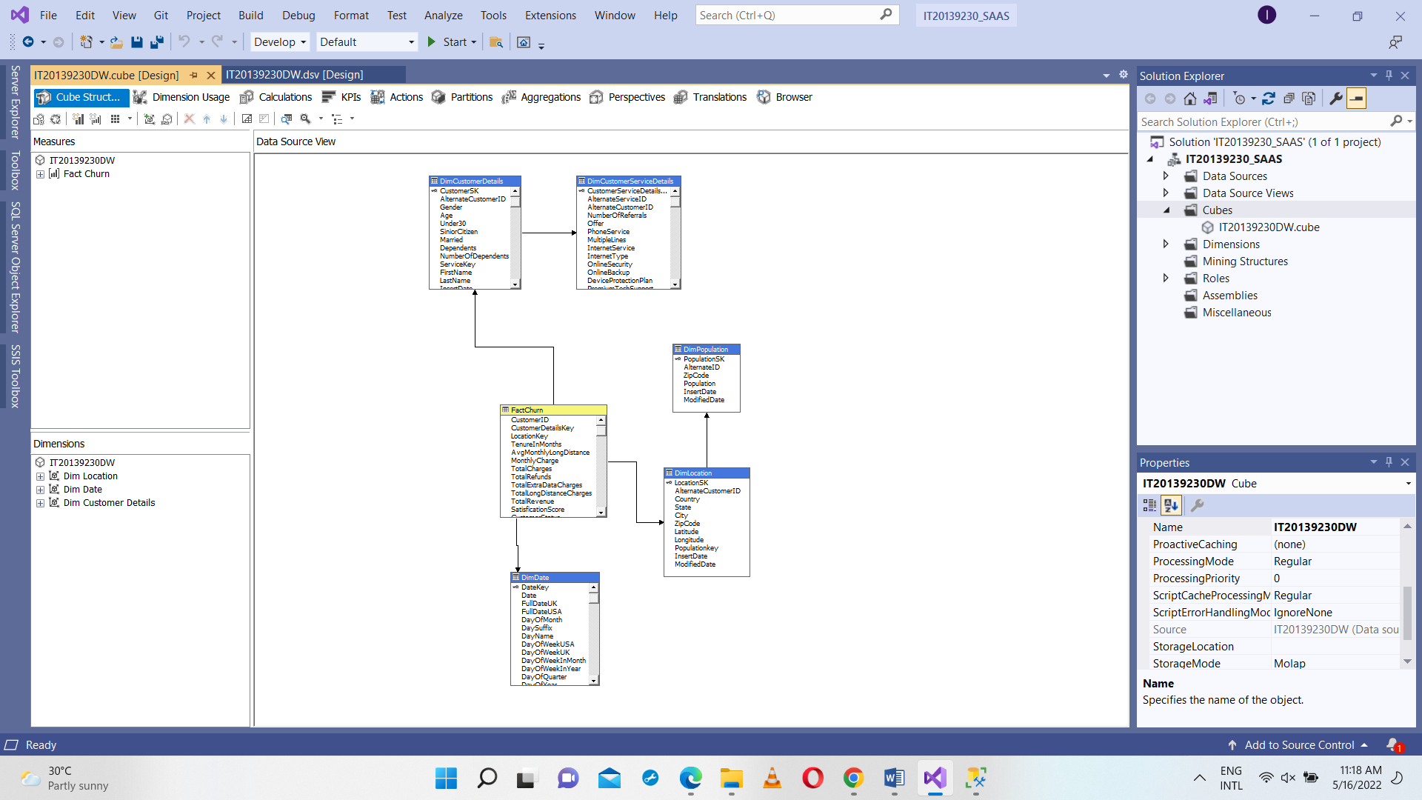

20139230DW.cube Design

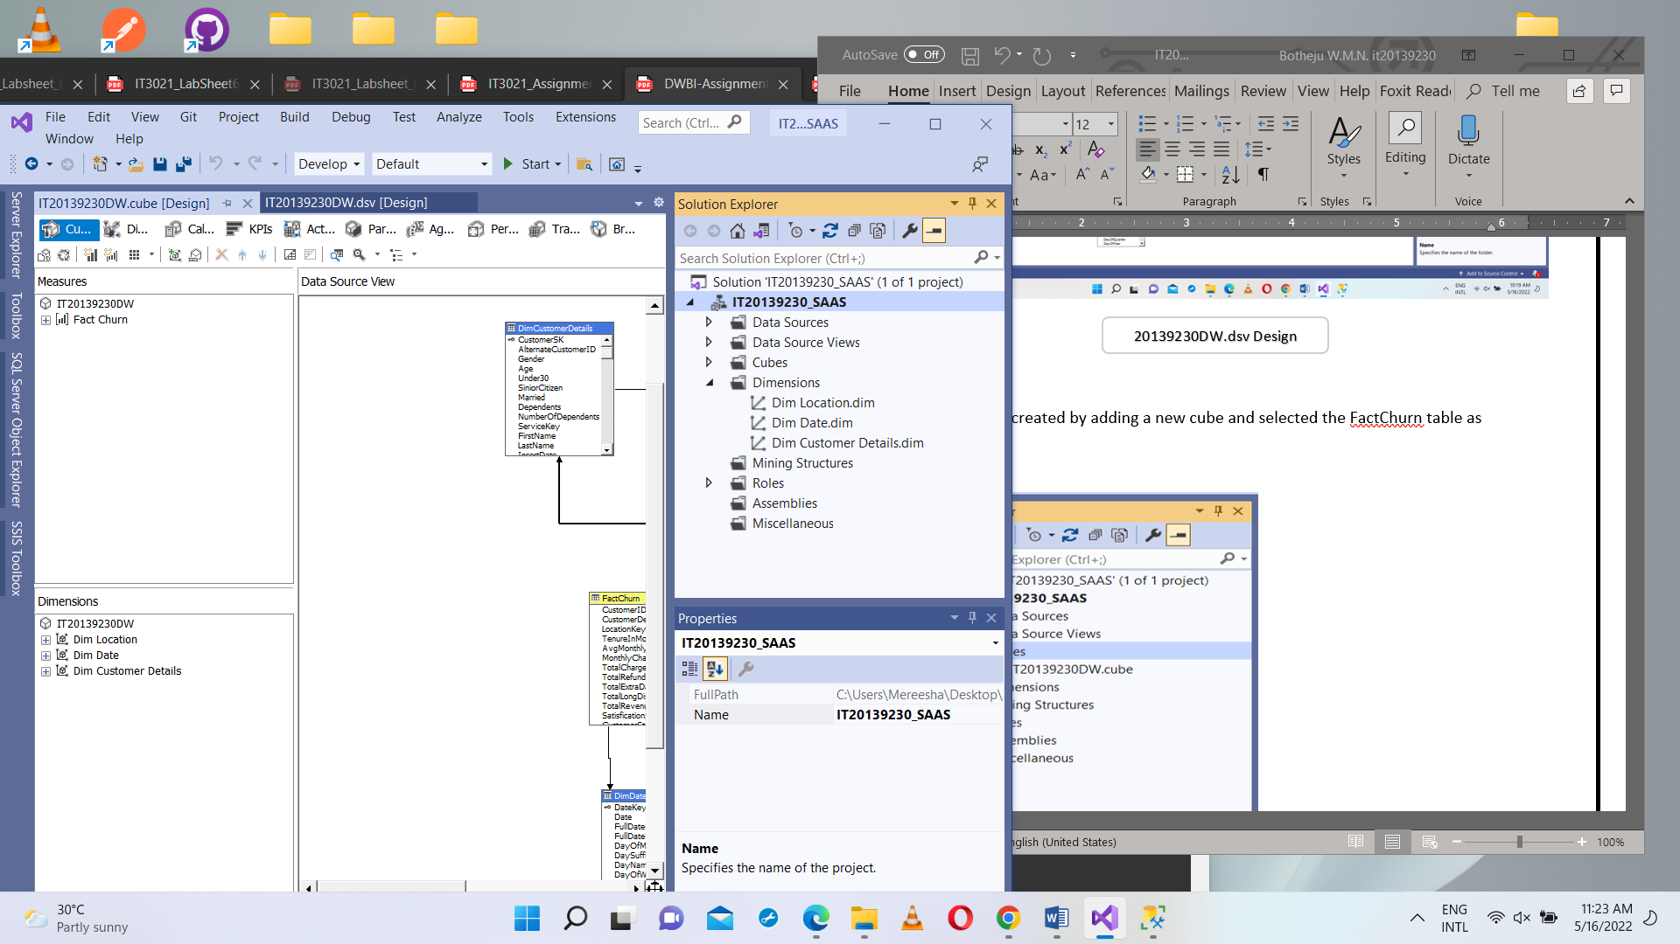

**Dim Location**

Selected all other attributes except Location SK, from the data source view and added into the Attributes.

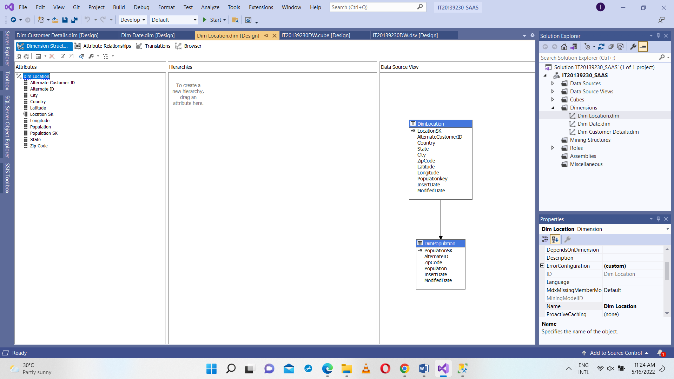

**Dim Date**

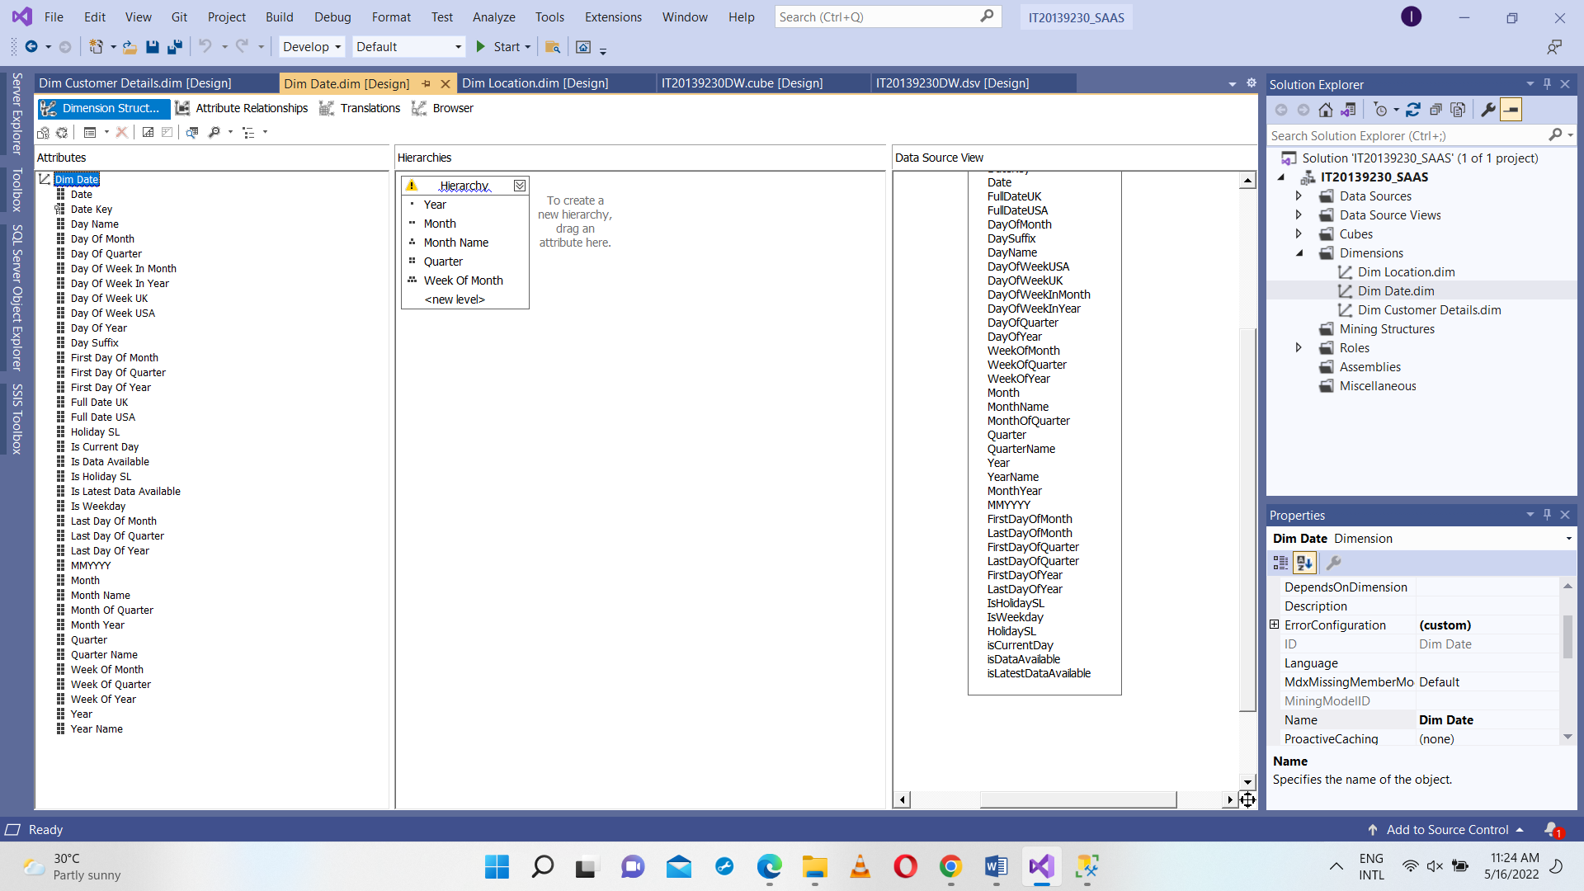Selected all other attributes except Date Key, from the data source view and added into the Attributes. And also a hierarchy was created for the easiness for the process of analyzing data.

**Dim Customer Details**

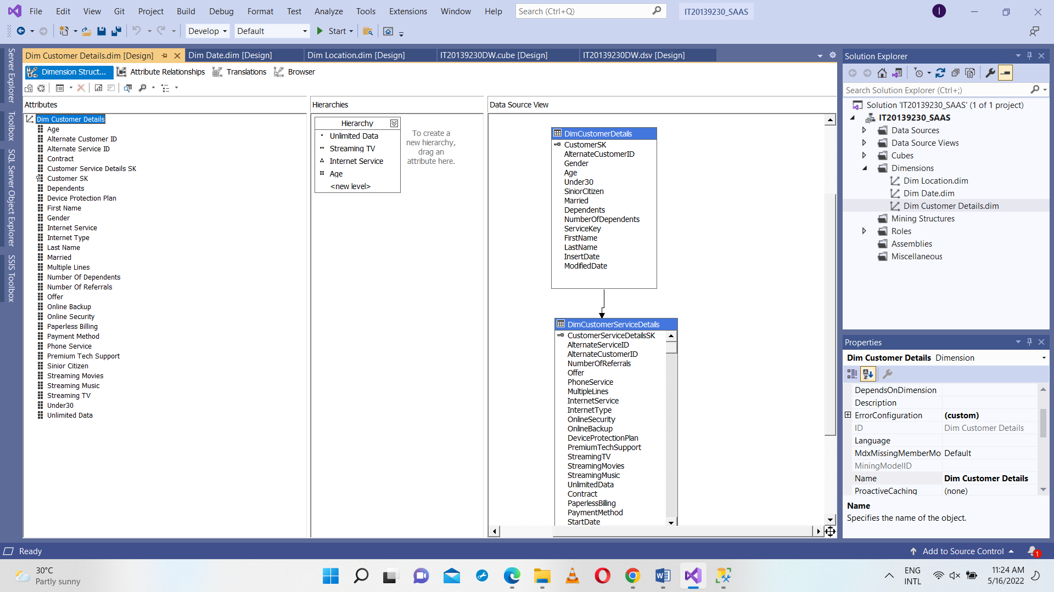Selected all other attributes except Customer SK, from the data source view and added into the Attributes. And also a hierarchy was created for the easiness for the process of analyzing data.

After all those were done IT20139230DW.cube was deployed to make sure steps have been followed properly so far.

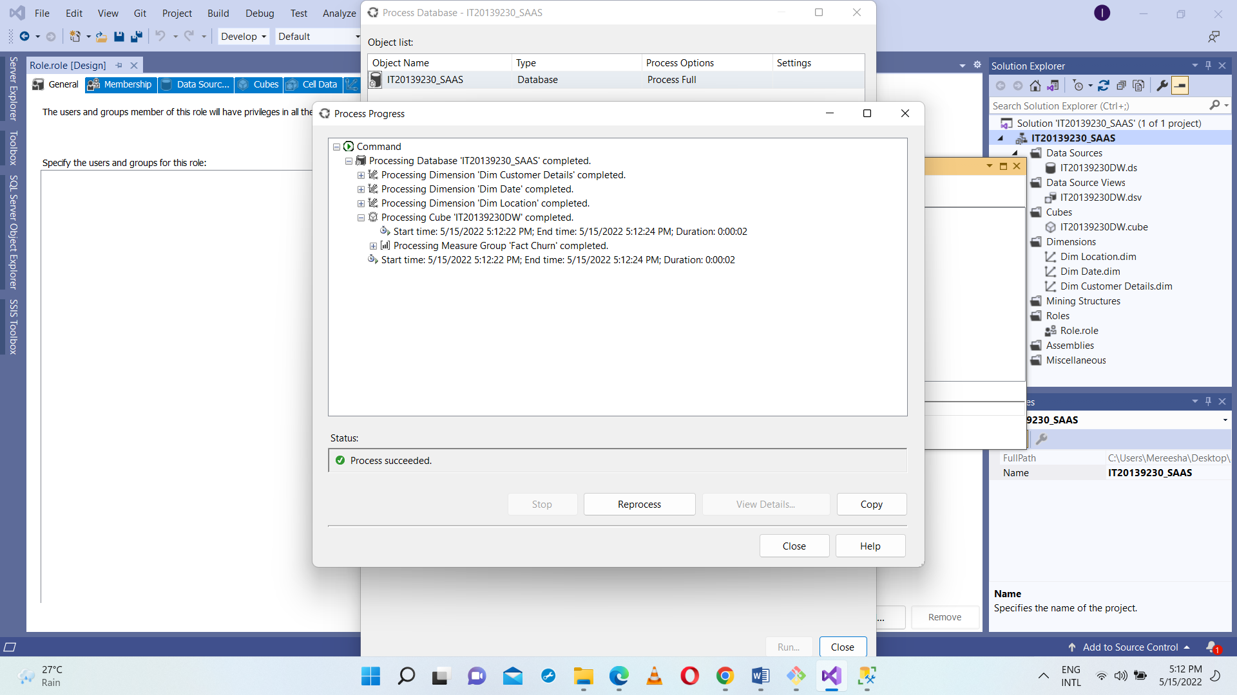

As the next step KPI Total Revenue KPI were created to address business requirements. The below KPIs were created accordingly

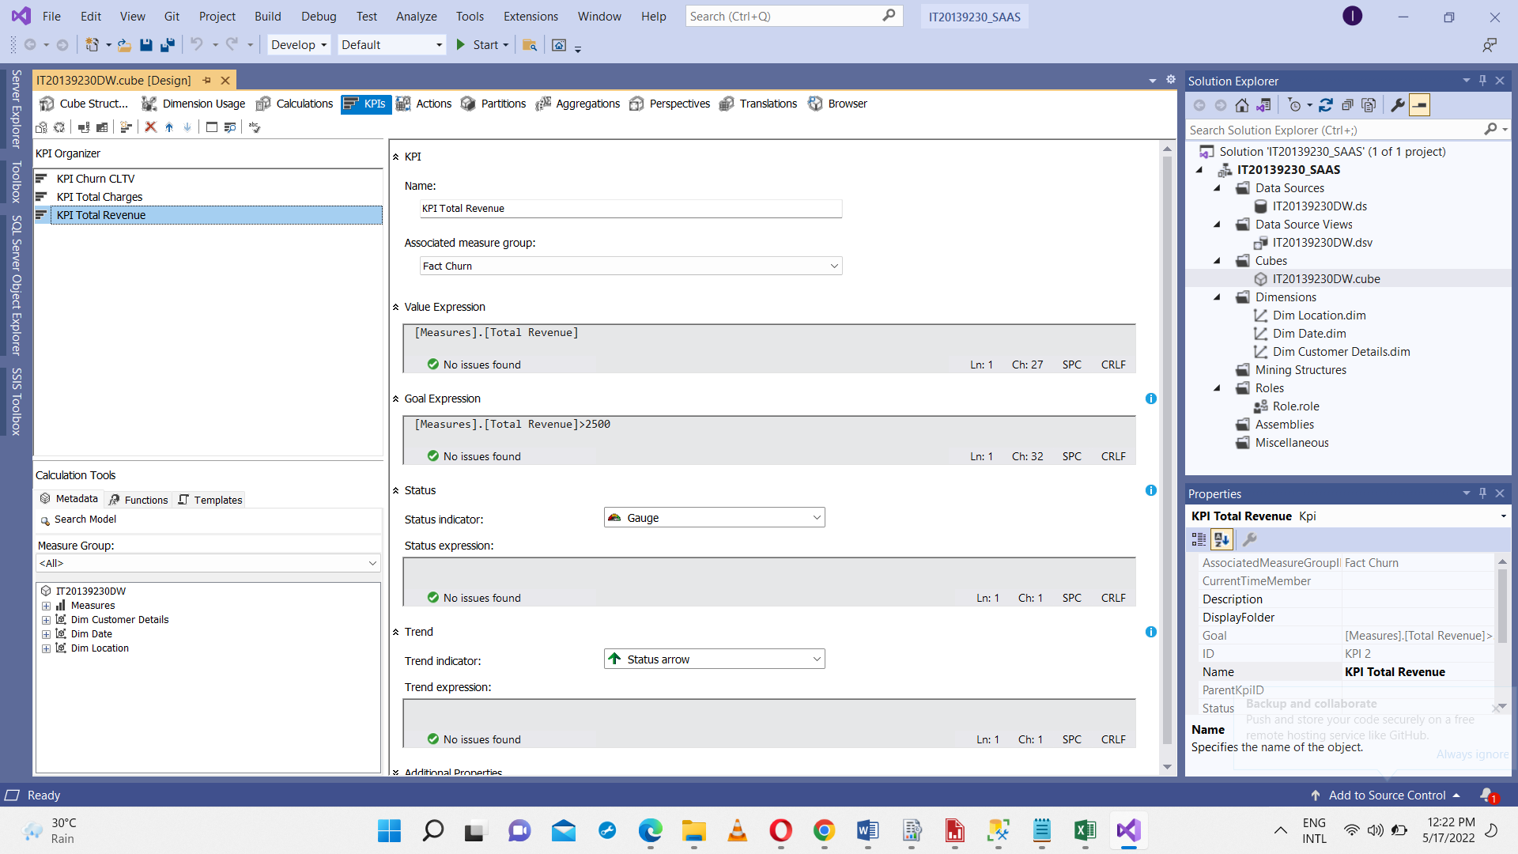

As the final step IT20139230Role role was created by defining permissions assigned to the role. As the last step of cube implementation, the cube was deployed.

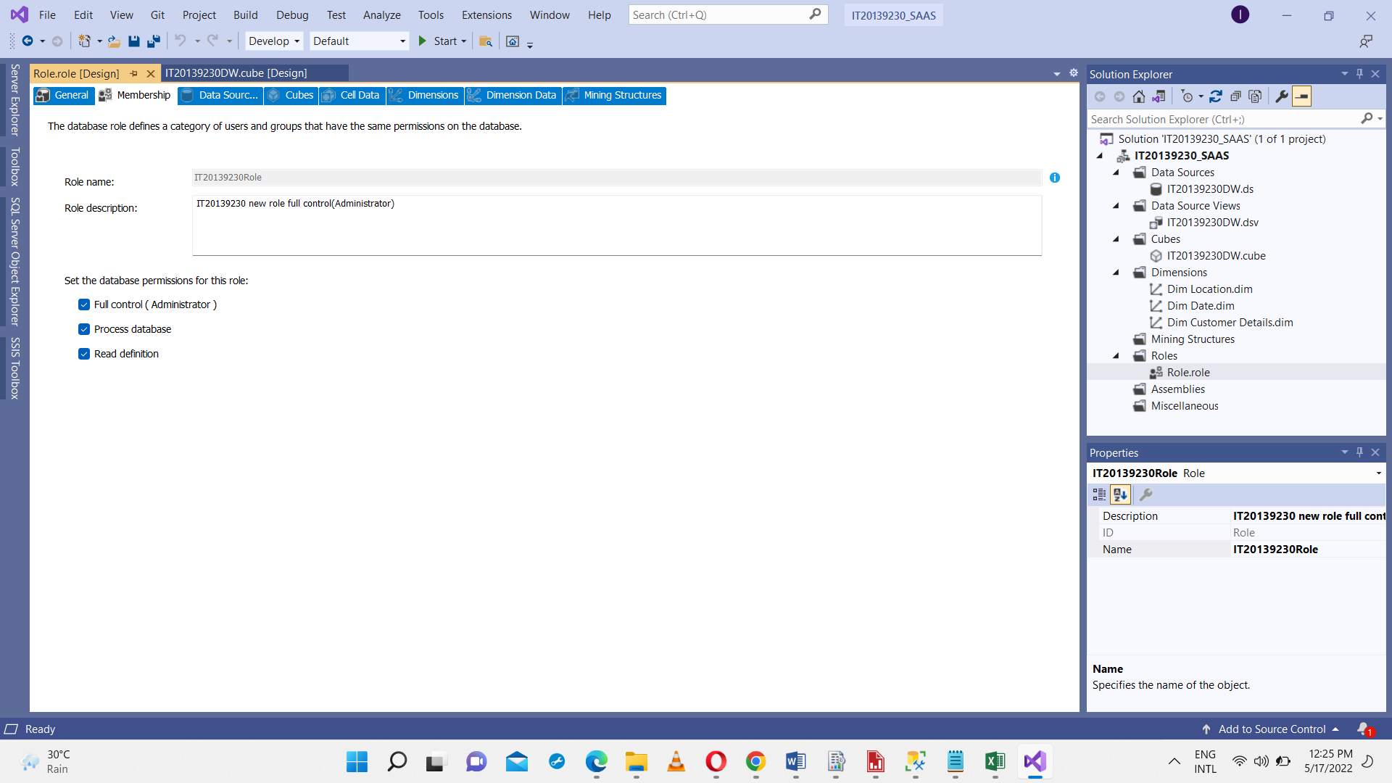

**Step 3: Demonstration of OLAP operations**

After deployment the created cube is shown in the SQL Server Management Studio

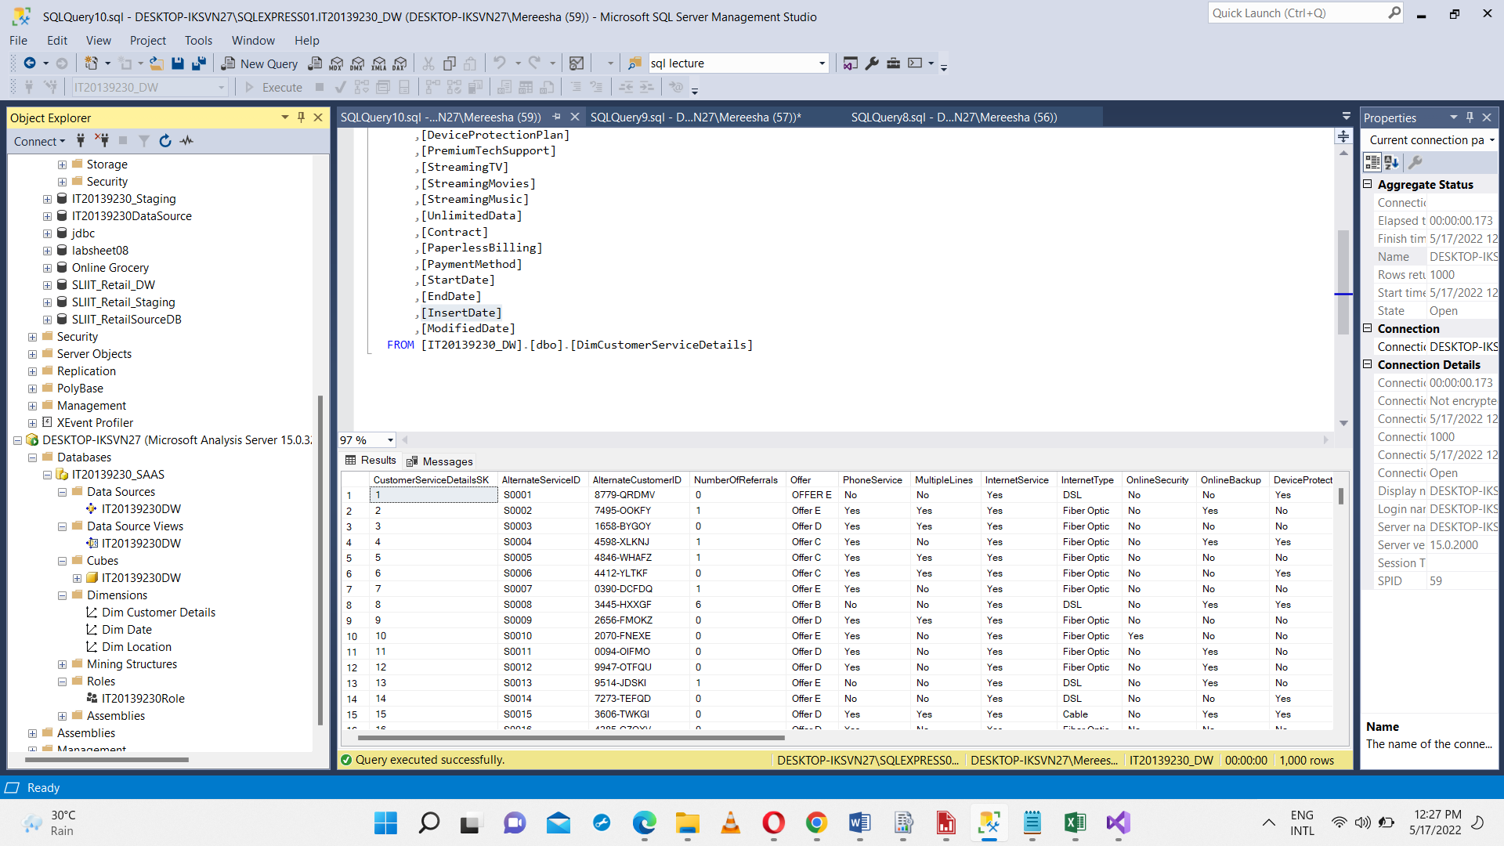

Connected to Excel workbook to the Cube and used connecting Excel workbook using features available in POWERPIVOT mode.

By dragging and dropping the necessary fields the MDX queries were generated. And extracting the generated MDX queries to Excel power pivot, reports were created.

Created Pivot Tables and Pivot Charts.

**Table 01**

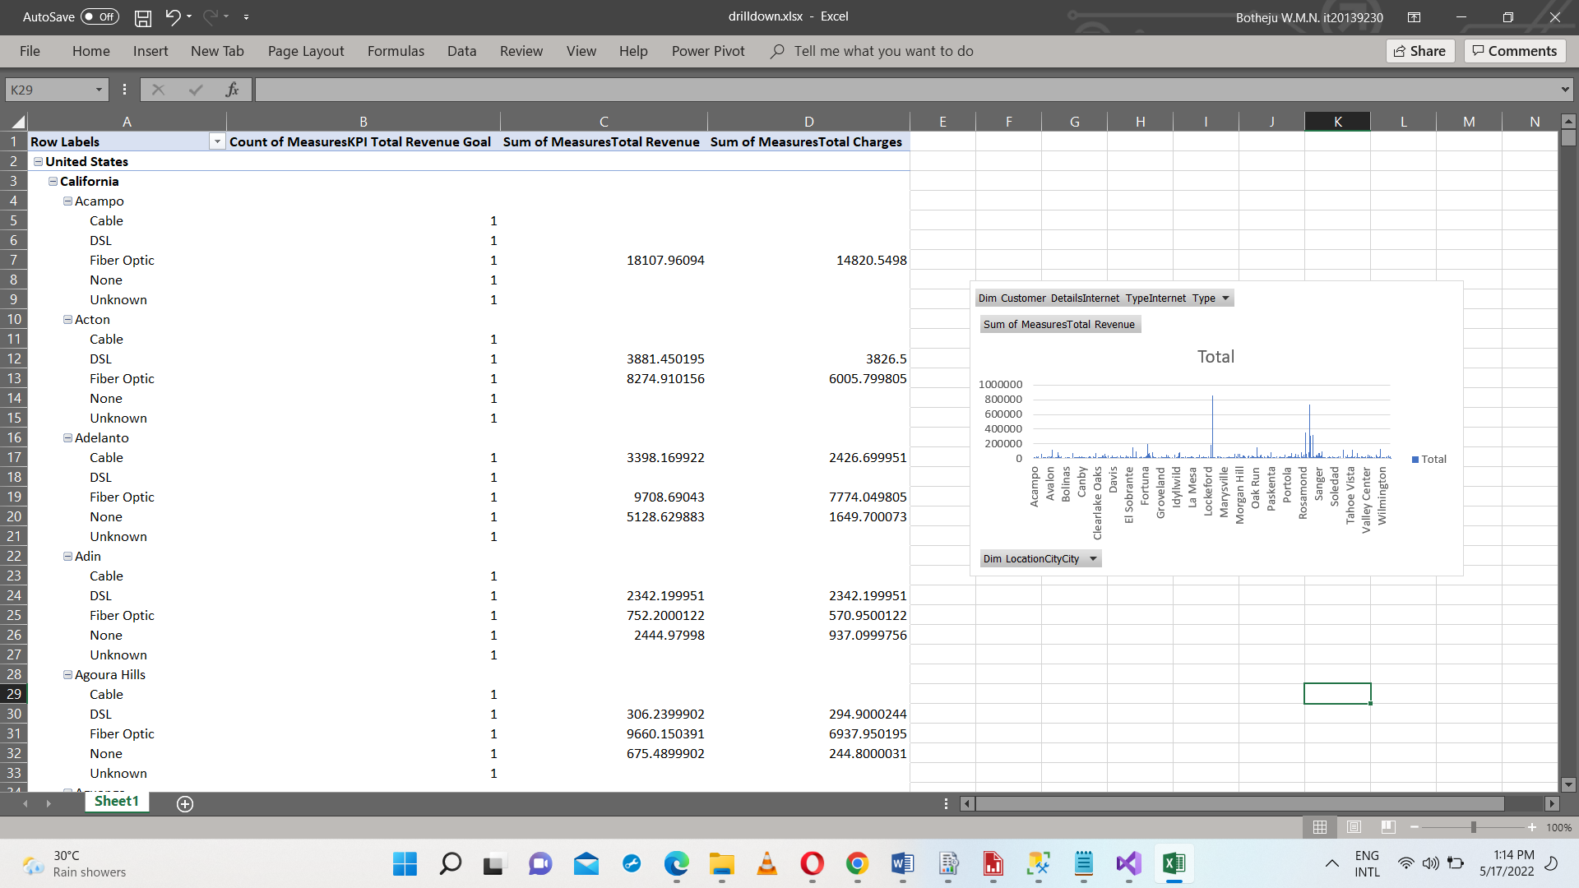This table analyzes Sum of the Total Revenue and Some of the Total based on Country, State and the Customer Internet Types to do so I have used Drill-Down and Pivot olap operations.

**Table 02**

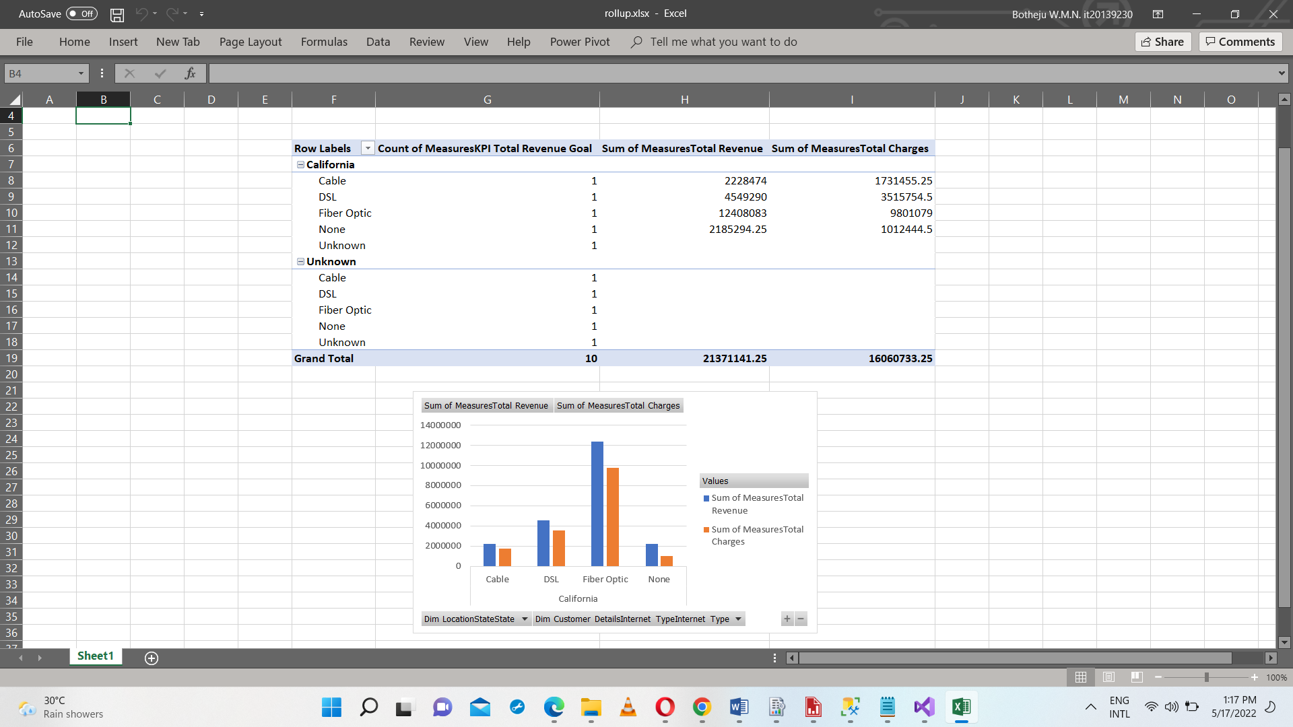This table analyzes Sum of the Total Revenue and Some of the Total based on State and the Customer Internet Types, to do so I have used Roll-Up and Pivot olap operations.

**Table 03**

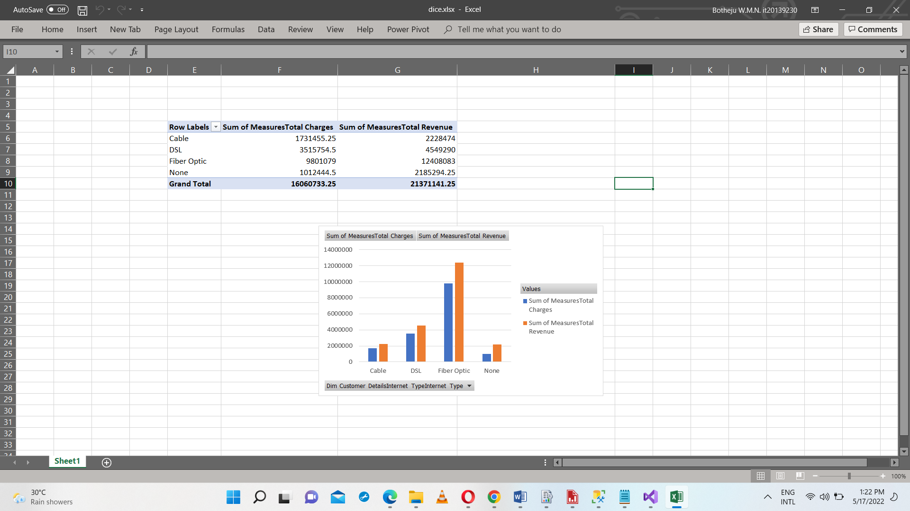This table analyzes Sum of the Total Revenue and Some of the Total based on the Customer Internet Types which are used by the customers, to do so I have used Dice and Pivot olap operations

**Table 04**

This table analyzes Some of the Total Charges based on the Cities, to do so I have used Slice and Pivot olap operations.

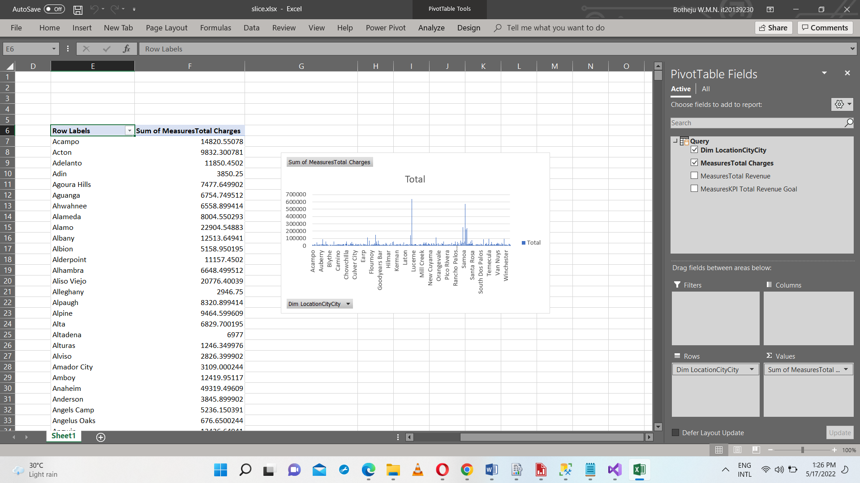

**Step 4: SSRS Reports**

Developed and publish following reports in SSRS Web Portal. Before generating SSRS Reports, SQL Server Services Configuration manager was configured and the web portal was accessed using the URL mentioned below:

<http://desktop-iksvn27/Reports/browse/>

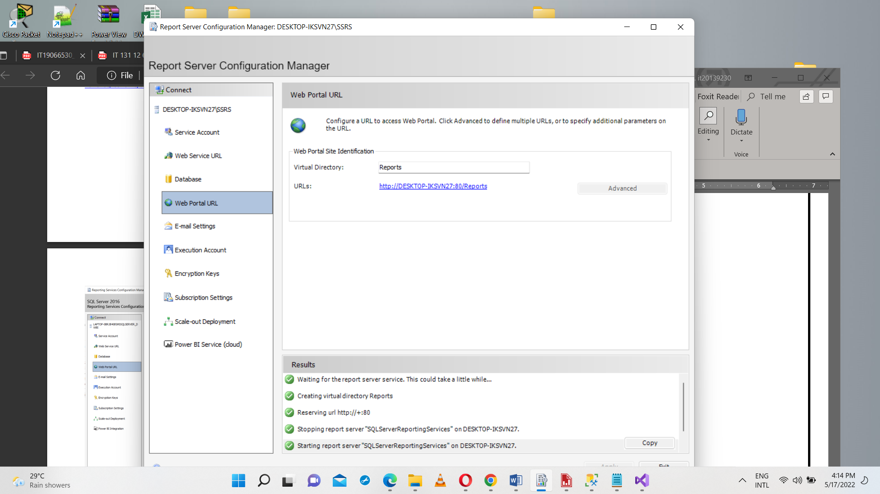

Next the SSRS project was created by giving the server name and data warehouse accordingly. Paginated reports can be created using SQL Server Data Tools or Report Builder. First step is to create a Data Source. Data source is a connection to the source of the data.

Next step is to create Datasets. Dataset is the actual data that will be loaded to be used the report visualizations.

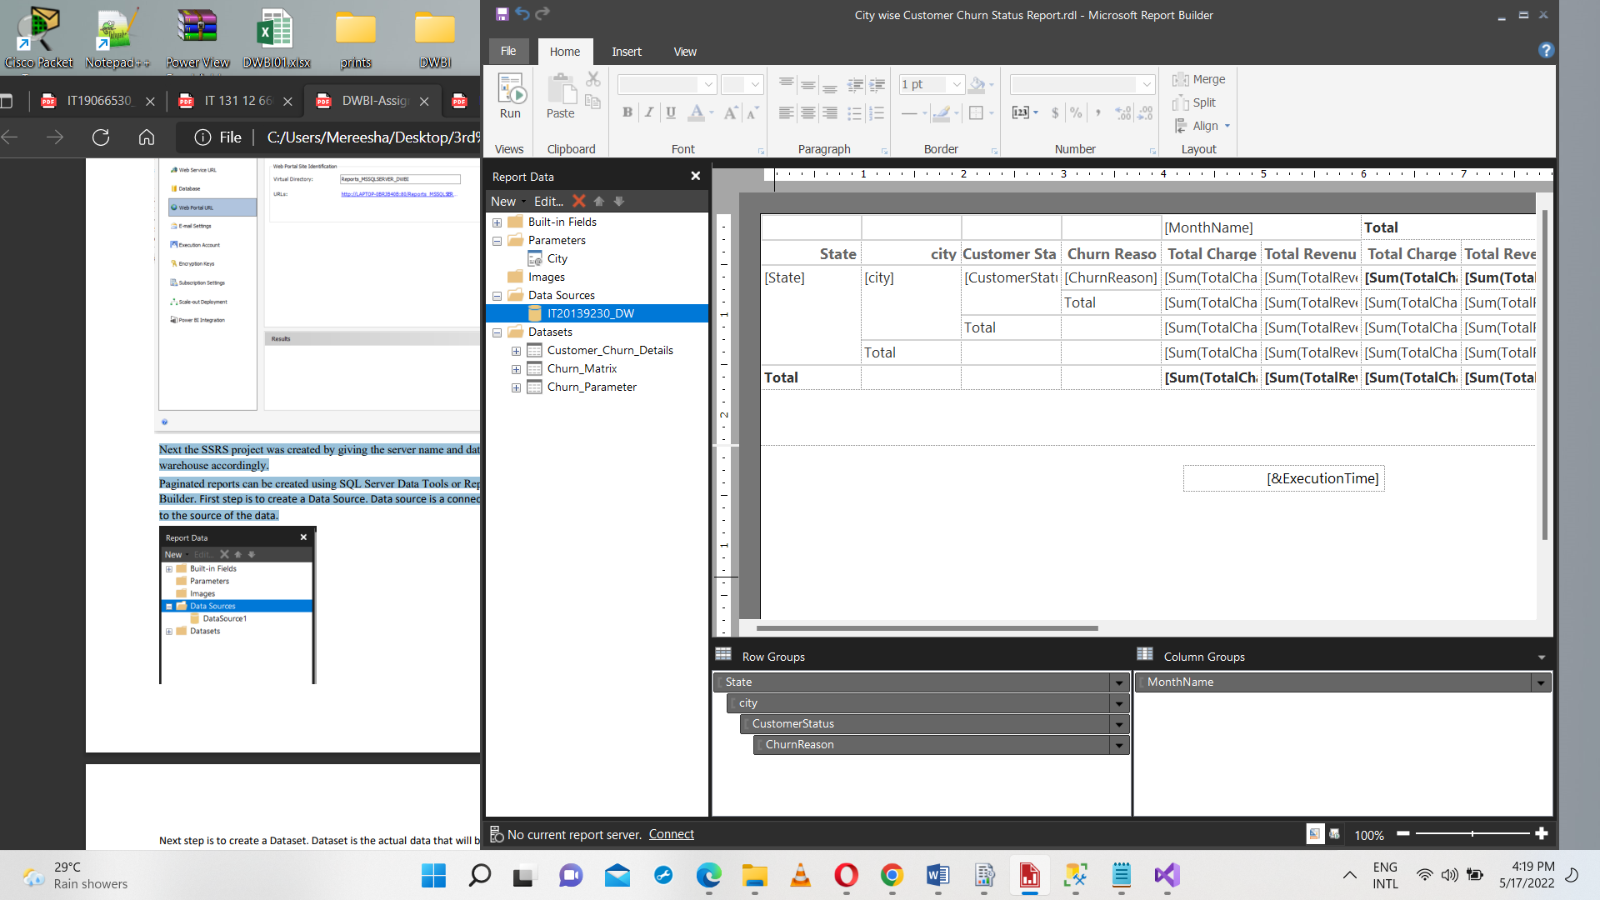Next step is to create the visualization in report.

**Query used for creating Reports**

select fc.CustomerID,fc.CustomerStatus ,fc.ChurnReason, fc.TotalCharges,fc.TotalRevenue, fc.MonthlyCharge, fc.SatisficationScore, fc.CLTV, dl.State,dl.city, dd.Date,dd.year,dd.MonthName,dd.Quarter,dcd.FirstName,dcd.Age,dcsd.InternetService,dcsd.UnlimitedData

from FactChurn fc

inner join DimCustomerDetails dcd on fc.CustomerID=dcd.AlternateCustomerID

inner join DimCustomerServiceDetails dcsd on dcsd.CustomerServiceDetailsSK=dcd.ServiceKey

inner join DimLocation dl on fc.LocationKey=dl.LocationSK

inner join DimPopulation dp on dl.Populationkey=dp.PopulationSK

inner join DimDate dd on dd.DateKey=fc.ChurnedDateKey

**Report 1: Report with a matrix**

At the point of selecting fields for Row groups and Column groups, dragged and dropped State and City to Row groups section and Month to Column groups section and Total Charges and Total Revenue to Values section.

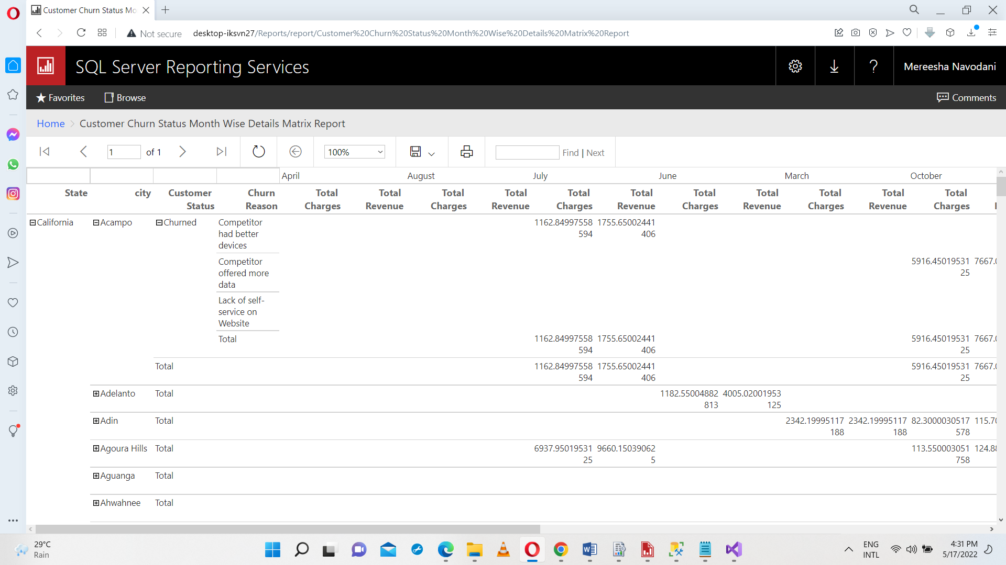

**Report 2: Report with more than one parameter**

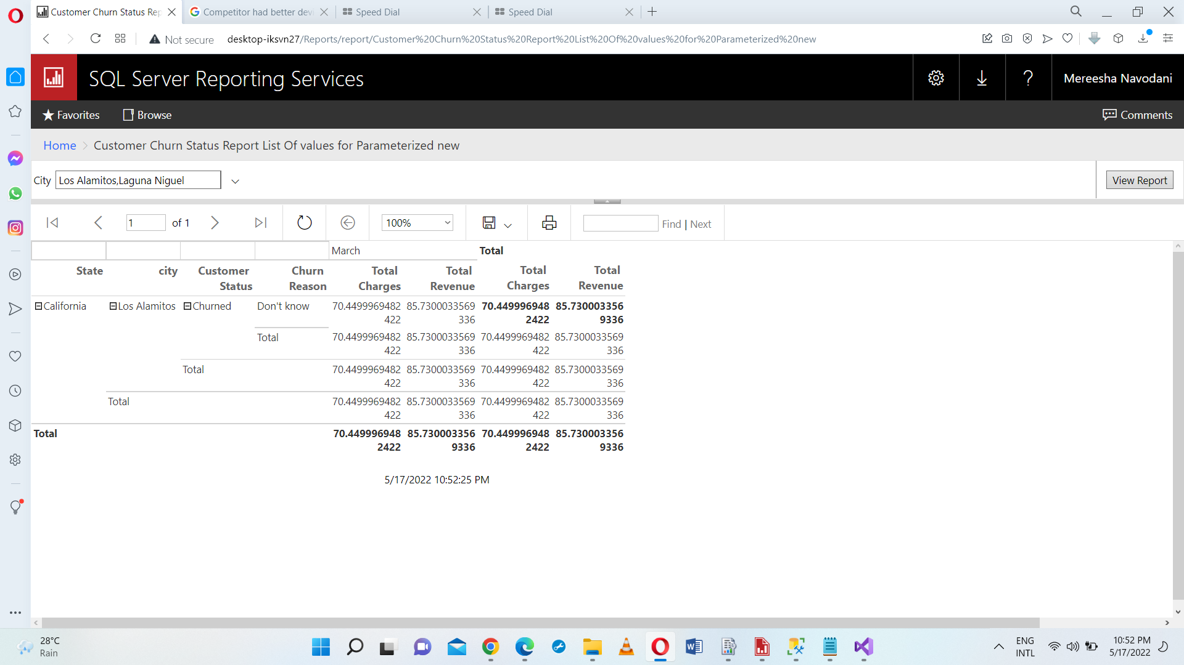User Can select a city and view report details to relevant for that.

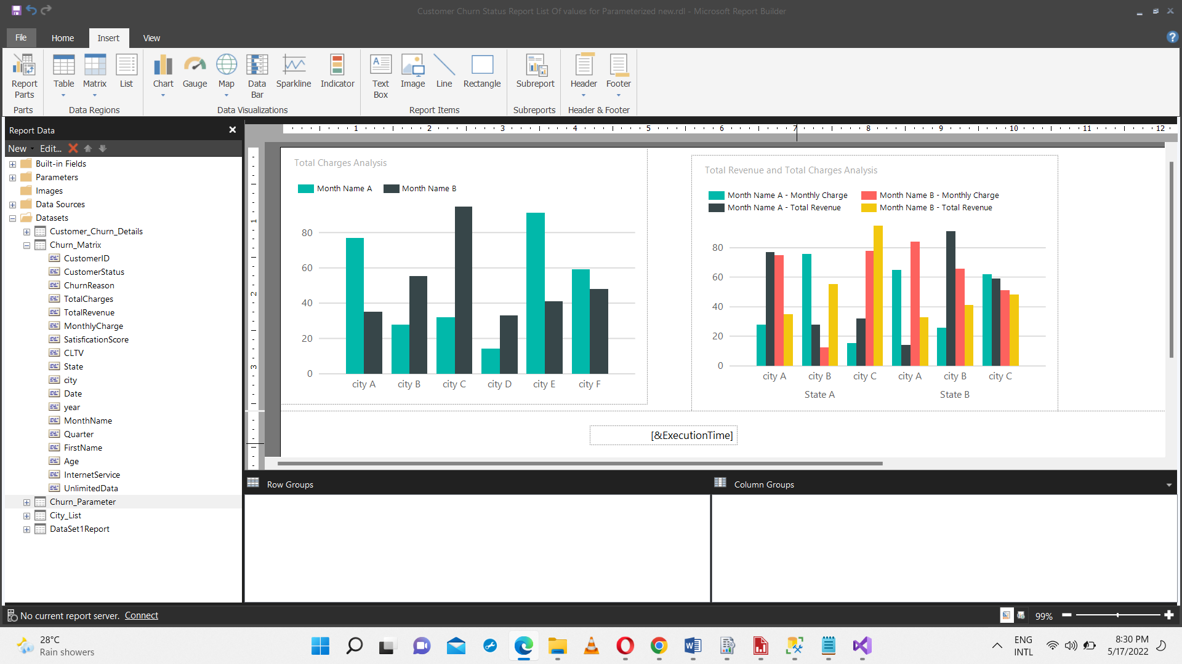

State and City wise Total Revenue and Total Charge Analysis

**Report 3: Create an SSRS drill-down report.**

At the point of selecting fields for Row groups and Column groups, dragged and dropped State,City,Customer Status,Churn Reason and Satisfication Score to Row groups section and Year and Month to Column groups section and Total Charges and Total Revenue to Values section.

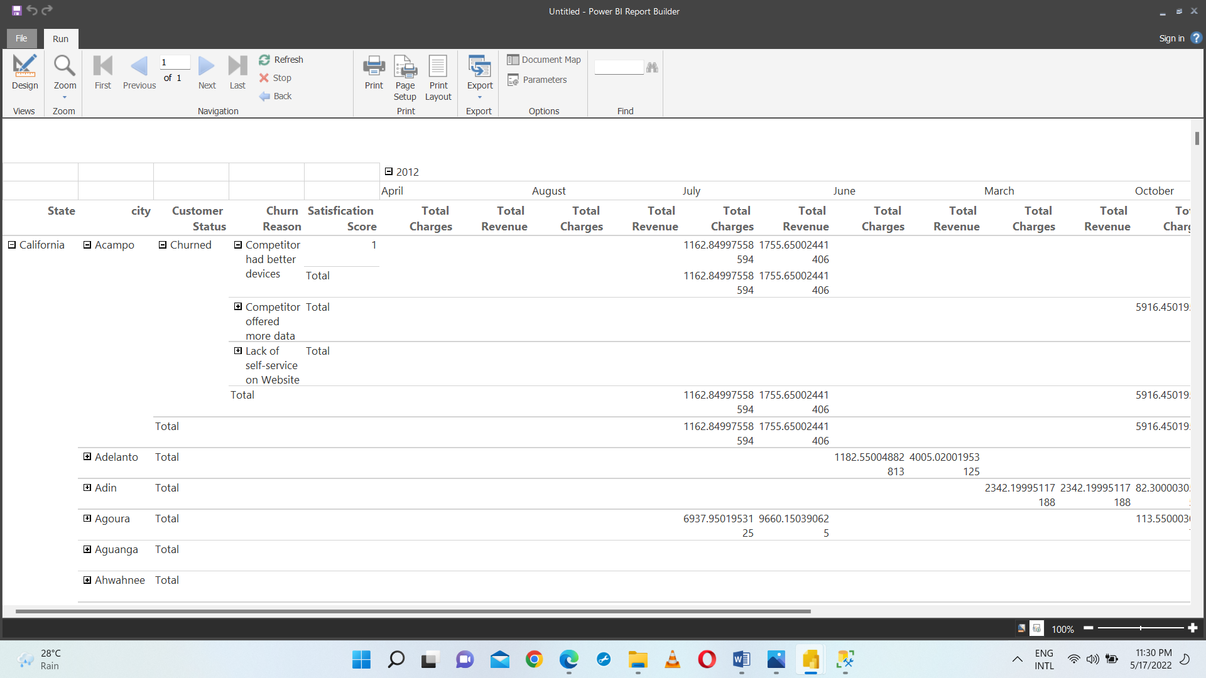

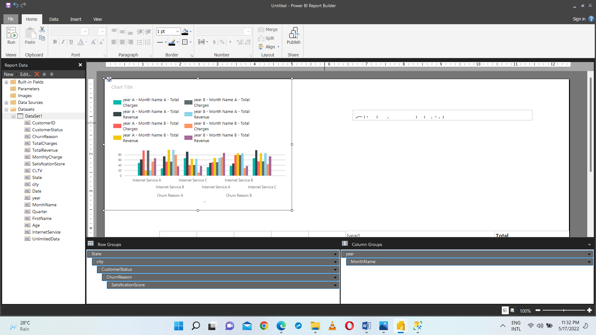

**Report 4: Create an SSRS drill-through report.**

At the point of selecting fields for Row groups and Column groups, drag and drop State, City, Customer Status and churn Reason to Row groups section and Month to Column groups section and Total Charges and Total Revenue to Values section. This report Also Used SSRS Matrix.



